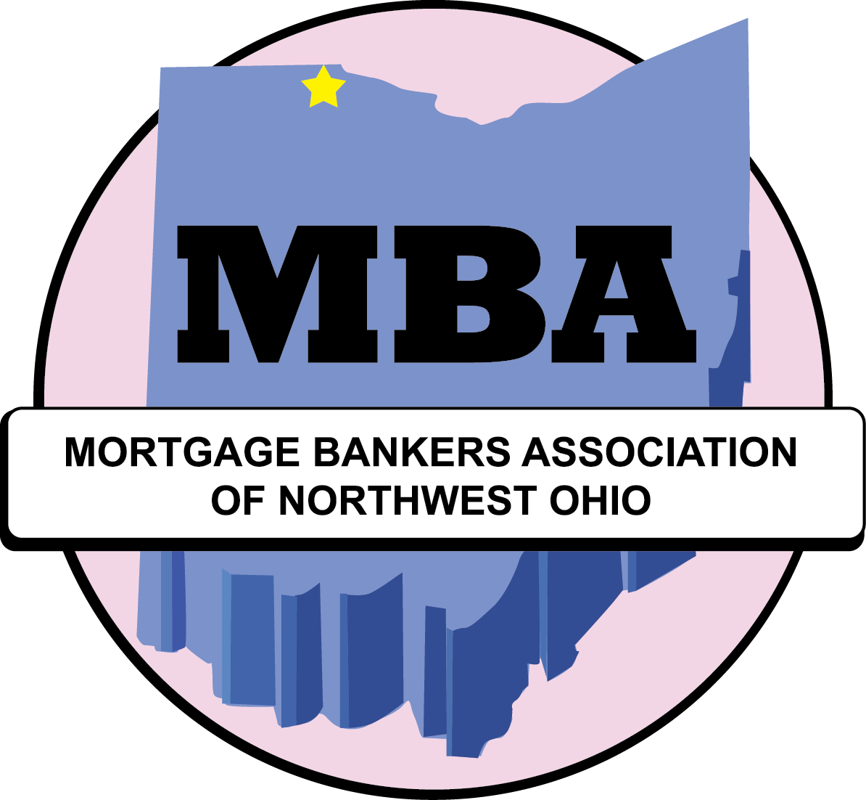

P. O. Box 8891, Toledo, OH 43623
mbanwo@outlook.com

You are invited
to become a member of

Mortgage Bankers Association
of Northwest Ohio

MISSION STATEMENT

The purpose of the association is to promote the welfare and success of the member companies, to improve their interaction within our industry and service to the northwest Ohio community.

We shall endeavor to provide continuing education and compliance awareness with all local, state, and federal laws pertaining to the industry to enhance the professional growth and development of our members.

We shall recognize the obligation for our members to act in accordance with the highest standards of business ethics, including, but not limited to the Mortgage Bankers Association Cannon of Ethics.

We shall support and encourage our membership to engage in fair, affordable housing initiatives that will promote homeownership for all segments of the community.

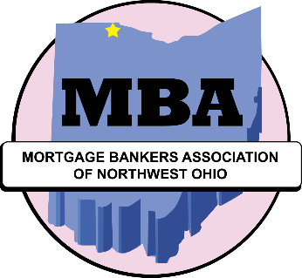

A LITTLE HISTORY…

MBA/NWO began in Toledo in 1988. The membership year runs from January through December. We are a non-profit unincorporated association.
Monthly meetings are generally scheduled for the third Tuesday of each month, with the exception of June, July, August, and December. Programs feature speakers of interest ranging from current industry events happening in Northwest Ohio and the mortgage and financial industry. Longer education programs may be scheduled when current topical information occurs.
The annual inauguration of officers and directors is a banquet held in January. An award is given in honor and memory of William Hodupp, one of the pioneers of independent mortgage banking in Toledo.
Several other special events, primarily social in nature, are scheduled throughout the year. The annual golf outing is named for Red Barron, one of the association’s founders and the first president. A guest bartender night and wine tasting event have also been popular events to raise money for charities. UT tailgate parties, chartered river cruises, and the Lights Before Christmas at the Zoo have been other fun events held in the past.

MORTGAGE BANKERS ASSOCIATION
of NORTHWEST OHIO
P. O. Box 8891 Toledo, OH 43623

www.mbanwo.com

2020

OFFICERS

President Rhonda Ball
Fifth Third Bank

Vice President Tony Brancatto
Ruoff Home Mortgage

Secretary Amy Brentlinger
Farmers & Merchants State Bank

Treasurer Mary Stefko
Farmers & Merchants State Bank

DIRECTORS

Two-year term Mike Beeler
Louisville Title

Josh Schonter
Fairway Home Mortgage

One-year remaining Kari Azzarello
of two-year term Howard Hanna Mortgage Services

Tom Wulf
First Federal Bank Midwest

Immediate Past President Stephen Micham
Union Home Mortgage

Administrator Christi Marino
mbanwo@outlook.com

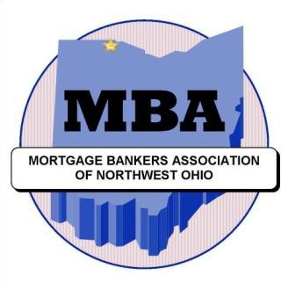

MEMBERSHIP CATEGORIES

LENDER / VOTING MEMBER

Any lender organized as a legal entity to do business in the State of Ohio who is engaged in originating, buying, selling, and/or servicing real estate mortgage loans. The company is the member, and any interested employee may participate.

Annual dues $ 250
(Payable annually or upon approval of membership; dues may be prorated for the membership year.)

ASSOCIATE MEMBER / NON-VOTING

Any legal entity organized to do business in the State of Ohio whose functions compliment and provide services for mortgage lenders such as (but not limited to) appraisers, title companies, surveyors, private mortgage insurers, fire and casualty insurance and/or agents, real estate brokers, attorneys, accountants, educators.

Annual dues $ 225

REALTOR ASSOCIATE MEMBER / NON-VOTING

An individual licensed Realtor in the State of Ohio whose function compliments mortgage lenders and who is also a member of the Toledo Regional Association of Realtors.

Annual dues $ 125

MORTGAGE BANKERS ASSOCIATION of NORTHWEST OHIO
Application for Membership
[ ] Lender [ ] Associate [ ] Realtor Associate

Name of Applicant (Company)
Date organized [ ] Corporation [ ] Partnership [ ] Other
Type of business
REGULAR MEMBERS (Check any that apply) [ ] Bank [ ] Credit Union [ ] Mortgage Banker [ ] Mortgage Broker [ ] FNMA Seller/Servicer [ ] FHLMC Seller/Servicer [ ] FHA Mortgagee [ ] VA Mortgage
[ ] Origination [ ] Servicing [ ] Investing [ ] Support/Supplier Service [ ] N/A
Business address (if addition area branches, attach) Phone FAX

Street address

City, State, Zip email address (attach additional sheet for additional email names/address)
Billing instructions:
Name(s) of owners/managing officers Title/position How long in organization/industry % Ownership

Number of employees
Is your firm a member of the Ohio Mortgage Bankers Association [ ] Yes [ ] No [ ] N/A
Member of the following industry related organizations:

Has your firm, or any Officers of your firm, ever been suspended by FNMA, FHLMC, FHA, VA, or GNMA? [ ] No [ ] Yes – if YES, explain fully by letter
Does applicant own and/or control, or is it owned and/or controlled by, or is it a subsidiary or affiliate of any other mortgage company, financial institution, construction or home building company or any other group? [ ] No [ ] Yes – if YES, explain.
Have any of your officers or has your firm been involved in bankruptcy, insolvency, made assignment for benefit of creditors, or been indicted for or charged publicly with fraud or misrepresentation. [ ] No [ ] Yes (if YES, explain fully by letter)
Industry references: Company Contact person/information

Enclosed Annual Membership Dues (proration considered) $ _____________________________________
APPLICATION SUBMITTED BY: (signature) (printed name)

TO BE COMPLETED BY MBA/NOW BOARD - - - - - - - - - - - - - - - - - - - - - - - - - - - - - - - - - - - - - - - - - - - - - - - - - - - - - - - - - - - - - - - - - -
Member Sponsor (name and company)
Member Sponsors (name and company
Board Approval: Date: Secretary/Officer
MBA/NWO APPLICATION R 02/2018

Mortgage Bankers Association of Northwest Ohio
P. O. Box 8891, Toledo, OH 43623

MEMBERSHIP DUES 2020

PAYMENT OPTIONS

( 1 ) PAY BY CHECK # ____________________________

( 2 ) PAY BY CHARGE CARD

Amount of payment authorized: $ ____________________
Lender $250 Associate $225 Realtor Associate $125

Type of account: MC VISA AM EXPR DISCOVER

Account Number _____________________________________________________

Expiration date ______ / ______ Security code (3 or 4 digits) _____________

Name on credit card ________________________________________________

Company ________________________________________________

Billing address ________________________________________________

Phone ________________________________________________

Email ________________________________________________

Mail check or charge card authorization to the post office box address
or email cc authorization to mbanwo@outlook.com

Don’t forget to include your (a) Membership Application, and
(b) a list of your company’s contact names with email addresses.
